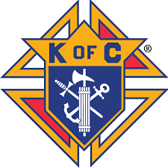
Msgr. John’ Knights of Columbus Council #11836
of St. Anne’s Parish will sponsor the Empire Safety Council Defensive Driving Course on Saturday, February 24, 2018:
From: 9:30 AM to 3:30 PM
Loation: St. Anne’s School Cafeteria
35 Dartmouth Street
Garden City, New York 11530
Save 10% on your collision liability rates for three full years, as well as four (4) points on driving violations!
Please fill out the form below and enclose your check in the amount of forty five dollars ($45.00) per person.
Check payable to: Knights of Columbus Council #11836
For additional information, call Donald DePol (516-775-3097)
Please mail or return the enrollment form to: St. Anne’s Rectory, C/O Msgr. John’s Knights Safety Driving Course, 35 Dartmouth Street, Garden City, New York 11530 no later than February 23, 2018.

Name: _______________________________________________________
Address:______________________________________________________ _____________________________________________________________
E-Mail Address: ________________________________________________
Telephone #: ___________________________________________________
There will be a lunch break as well as free donuts and coffee available.
This is an opportunity to bring your young driver who might be on your policy for free
however no certificate will be issued to them.

